11th April 2016

### YOKOHAMA tyre to come factory-equipped on Toyota’s new Prius

Tokyo – The Yokohama Rubber Co., Ltd., announced today that its tyres have been selected by Toyota Motor Corporation as original equipment for the new model of the automaker’s popular hybrid vehicle “Prius”. In Japan, Oceania and Europe, the Prius will now be equipped with “BluEarth E70” tyres, while Prius models sold in North America will roll off factory lines on “BluEarth S34” tyres. In other countries, the “ASPEC A349” tyre will be used. The OEM tyre sizes are 215/45R17 87W for the “BluEarth E70” tyres, P215/45R17 87V on “BluEarth S34” tyres, and 195/65R15 91H for the “ASPEC A349” tyres. The new Prius was launched in Japan on 9th December 2015, and is subsequently scheduled for successive launches in other countries.

The “BluEarth E70” and “BluEarth S34” feature the basic design and materials technology of YOKOHAMA’s global “BluEarth” tyre brand, developed with the underlying concept of “environmentally, human and socially friendly”. As such, the tyres provide increased safety and comfort while contributing to higher fuel efficiency. The “BluEarth” line-up includes tyres suitable for various markets, with the “BluEarth E70” targeted for use as a summer tyre on passenger vehicles and the “BluEarth S34” an all-season model. “ASPEC A349” is a summer tyre on passenger vehicles, which provides superior drivability, safety and comfort.

YOKOHAMA is aggressively pursuing tyre development based on its advanced “BluEarth” tyre technology, and the resulting tyres are increasingly being adopted as original equipment on many new model eco-cars and hybrid vehicles.

[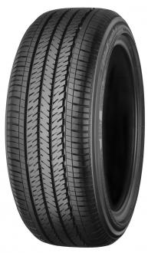](https://www.yrc.co.jp/release/download/download.php?no=2607&lang=en)

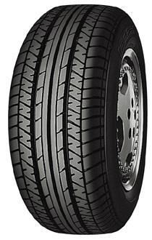[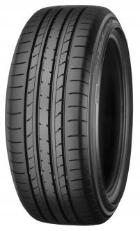](https://www.yrc.co.jp/release/download/download.php?no=2607&lang=en)

“BluEarth E70” “BluEarth S34” “ASPEC A349”

*Tyre shown is a different size from tyres used on Prius (Wheel shown is*

*not original equipment）*